**Big Data, Internet of Things and Artificial Intelligence; Survival Kits For The Oil And Gas Industry In The Fourth Industrial Revolution.**

**­­ABEGUNDE ADEBOWALE NATHANIEL**

(Department of Geology, University of Ibadan, Ibadan, Nigeria)

Email: [aanathaniel@gmail.com](mailto:aanathaniel@gmail.com); Phone contact: +2348103617151

_____________________________________________________________________________________________

**ABSTRACT**

With the invention of electric cars and renewable energy resources such as solar, the world is gradually drifting from the utilization of oil and gas for daily consumption to these more eco-friendly power forms and technology. As a result, industries are turning to the offspring of the fourth industrial revolution to survive in this era of emerging technologies. This paper reviews the utilization of Big Data analytics, as an emerging trend, in the upstream petroleum industry, the utilization of Internet of things to solve connectivity problems and also the use of artificial intelligence which includes pattern recognition, machine learning and deep learning techniques to find immediate insight and improvement potential from existing, unstructured and new streaming data. Thanks to big data and Artificial Intelligence, models can be built and simulations created by analysts, to explore how minor tweaks to a certain area of operations could have big impacts on the productivity or efficiency of another.

This paper also features the prediction of Brent crude oil prices using “Prophet”, a Machine Learning library for time series prediction.

**Keywords: Machine Learning, Deep Learning, Big Data, Artificial Intelligence, Internet Of Things, Python, R, Oil and Gas Industry.**

**INTRODUCTION**

The fourth industrial revolution since its onset, has set fears in the mind of the people. The fear of workers being replaced by machines, amongst others still rocks the atmosphere. However, the fourth industrial revolution should be seen not as a threat but a plus for efficiency. Using Machine learning in the oil and gas sector will enable skilled workers to be more efficient in carrying out their duties, save them from conducting needless tasks and foster a safer industrial environment.

The fourth industrial revolution should help Oil and Gas companies answer the following questions: ‘How much of this industrialisation have you tapped into’?, ‘How much should you tap into’?, and ‘how do you allow this industrialisation emerge in your companies today’?

The advent of electric cars and gradual steps taken by giant economies in the world to live in a cleaner, greener environment free from fossil fuels have led giant oil and gas companies to rethink strategies and approach to production. As a result, technologies of the fourth industrial revolution especially Big Data, Artificial intelligence and Internet of things are now much sought after in the oil and gas sector to optimize production, reduce environmental effects and reduce unnecessary operation cost.

**INTERNET OF THINGS (IOT)**

Internet of things (IOT) opens room for connectivity among devices, machines and other tools to communicate with each other. This can help Oil and Gas companies in data collection of various parameters via sensors such as pressure and temperature of the well amongst other parameters in intervals of seconds or minutes. According to intelAI and LUX. IOT solutions are capable of the following;

* Create better solutions faster
* Lower development and completion costs
* Optimize oil recovery
* Reduce well intervention and maintenance costs
* Improve safety and environmental performance
* Optimize energy generation and consumption.
* Siesmic Data Interpretation
* Well planning for optimized economics
* Formation testing fluid sampling
* Crude logistics and trading optimization
* Synthetic well logs
* Rod pump optimization
* Reservoir management
* Distributed acoustic and temperature measurements interpretation

These applications are a mix of potential ideas and already proven solutions (https://luxresearchinc.com).

Across the 3 business segments of upstream oil and gas that is Exploration, Drilling and production, have problems that can be better attended to using IOT.

Exploration involves Seismic acquisition, Data Processing and interpretation. Drilling involves Real-time monitoring, predictive maintenance and completion. Production involves real-time monitoring, reservoir simulation, recovery optimization. Other problems could include asset management, safety and compliance and finally logistics.

Figure 1 Highlighting problems in the business segments of the upstream Oil and Gas operations(Intel IoT Solutions for Upstream Oil and Gas)

In Nigeria, Shell have taken advantage of this technology to drive her connectivity space and improve her monitoring and operations capabilities (http://enterpriseiotinsights.com). In 2016, Shell deployed pipeline surveillance and wellhead monitoring to her remote infrastructures in the Niger Delta. This automation and infrastructure technologies provides a platform of support using remote field data while optimizing operational efficiencies. This has led faster data management, faster analysis and provision of insights into field processes hence a safe and fully optimized field operation. Furthermore, oil wells being exploited by shell are trapped thousands of meters in the sub surface in unstable areas and conditions. To therefore optimize operations, shell installed thousands of IOT sensors on its equipment which includes pumps and valves, enabling her engineers to monitor real time measurements in order to optimise each process.

According to shell, this technology has projects to increase production, reduce downtime and improve the overall recovery of oil and gas while reducing costs and minimizing safety risks.

**CASE STUDY**

Softweb solutions, a Texas – based company that helps oil and gas businesses improve or maintain equipment performance and build a safe working environment built IoT Connect. IOT Connect is a software that analyses using Machine Learning algorithms. Sensors attached to pumps, valves and other machines gauges collects data, and this data is being stored somewhere in the cloud after which it’s being analysed by their algorithm. These algorithms have been trained on data that shows the proper functioning of the pumps, gauges and valves and when these machine parts takes in data that’s different from the one at which it was trained, and indicator warns personnel indicating the parts of the machinery that has developed faults and recommending that they be repaired immediately. They have also deployed solutions to remotely monitor and conduct predictive analysis on compressors, collecting data such as temperature, oil pressure, system pressure and other parameters over a well secured connection. With this technology, operation costs have been drastically reduced.

**BIG DATA**

The use of the word Big Data have been used in recent times to quantify huge volumes of data. This description is however incomplete without putting into consideration the 5V’S associated with it. These V’s was formerly 3 in number namely; Volume, Variety and Veracity of which Laney described them as the three dimensions of challenges in data management. IBM later introduced Veracity as the fourth and Oracle introduced Value. Therefore, any form of Data that is characterised with the above mentioned five attributes can be classified as big data. Structured, Unstructured and semi-structured are all type of big data. Data in the fourth industrial world drives decision making.

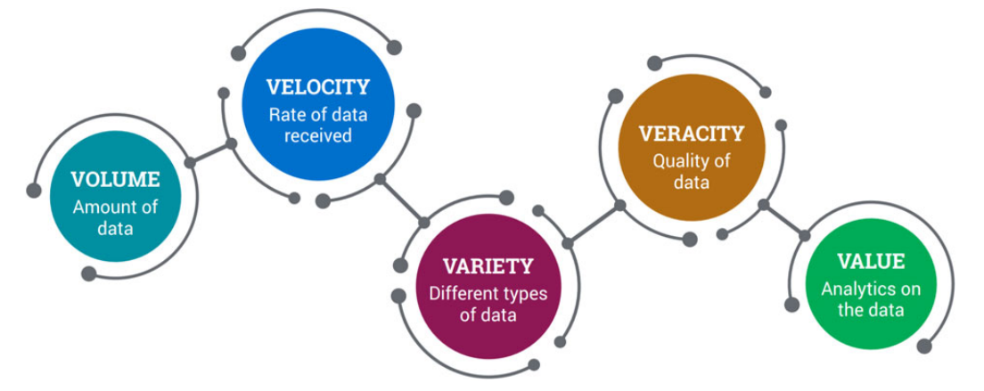

Figure 2 The 5V's of Big Data(Quorum, 2016)

In the Oil and Gas industry, millions of data is generated daily with an estimation of over 1.2 terabytes generated. Processing these large volumes is not new to the industry however, geophysicist, geologists and reservoir engineers have been using parallel processing capabilities of High-Performance Computing (HPC) to crunch petabytes of data since the late 90’s. Modern drilling depends actively on data as the industry is currently pursuing enhanced oil recovery by using data generated from wells such as the production history to achieve better production rate and recovery efficiency. All the aforementioned was as a result of the high cost of drilling a deep water well which is estimated to be well over a $100 million (Marr, 2015)

Furthermore, Pattern recognition during big data analysis can help save lives and millions of dollars equipment as early detection of anomalies in machines used during drilling can help put an end to such an exploration before a blow-out occurs. Moreover, changes in environment occurring makes big data very useful as real-time data involving the geology of such an environment can make sure drilling operations takes place at the exact location hence enhancing drilling.

In terms of exploration, there is evidence to show the edge of big data analytics to discover hydrocarbon deposits which on a normal hand would require intense manpower, heavy logistics and time. However, big data analytics with pattern recognition can help in identifying seismic traces which have previously gone unnoticed. The success of drilling operations could also be predicted after working on data collected from soil and equipment data and weather.

Big data is the engine of the fourth industrial revolution as Artificial intelligence won’t be able to survive without any data to feed on hence a bright future for the oil and gas industry which tends to generate a lot of that. As it stands, big data is the new oil even in the Oil and Gas industry.

**ARTIFICIAL INTELLIGENCE (MACHINE LEARNING)**

The idea that a machine can exhibit the same level of intelligence of a human being has captivated writer’s audiences alike for decades. This technology has been exhibited in fiction movies from super human androids to cyborgs. The need for data analysis and translation to actionable sights not only in the oil and gas industry but in other fields and this is where Artificial Intelligence(AI) and Machine Learning(ML) makes the difference. Major areas in the upstream such as exploration, production, location of new reserves and many more. This technology has the potential of more accurate detection of reserves.

Machine Learning on the other hand has the capability to learn without being programmed explicitly. Machine learning studies data and make predictions based on probability. Companies now leverages AI solutions in drilling, accounting, and other areas by using information gathered from data visualisation to make predictions taking into context the demands and financial reports to plan for the coming operations. Learning from past failures, machine learning can help in making better decisions and solve problem which initially could have been an arduous task for workers. In the next few paragraphs, I’ll be going through certain oil and gas companies, and their collaboration with tech giants to bolster AI applications in their businesses.

To begin with, Shell released her AI virtual assistant (Shell LubeChat) with the intention of helping her customers to navigate their large database. With its availability in over 138 countries and 21 languages, shell aims to help customers discover products using natural language.

According to shell, her chatbot handles over 100,000 data sheets for 3,000 products, gives information on 18,000 different packs, understands 16,500 physical characteristics of lubricants (Emerj.com 2019).

Furthermore, ExxonMobil in 2016 announced that it will be working with MIT to design AI robots for ocean exploration. ExxonMobil’s AI robots are expected to navigate oceanic regions to detect oil seeps in such environment. Natural seeps occurs in rocks found in the ocean floor when oil escapes these rocks.

Total in 2013 launched the Total’s ARGOS challenge (Autonomous Robot for Gas and Oil sites) which was aimed at building the first autonomous surface robots with the ability to operate on oil and gas sites, with a support of €600,000 and a prize of €500,000 In 2017.

In addition to exploration, AI applications has also been deployed in Business intelligence as this now gives business leaders an overview of possible AI initiatives in the business aspect of the industry.

In conclusion, AI and ML applications have also been deployed in Geosciences. These areas includes reservoir characterization, risk mitigation, sub surface etc.

**PREDICTION OF BRENT CRUDE PRICE USING MACHINE LEARNING**

**Overview**

Crude oil by far is one of the most prominent energy resource in the world and it leads in energy production, with almost a third of the world population depending on it for consumption. Volatility in oil prices in recent times and beyond have led to oil and gas companies watching out for optimization.

These fluctuating prices plays an important role in global economy by giving a modest boost the activities of the global economy, although to the detriments of oil firms (Hussain et al., 2015). Therefore, the usefulness of Crude oil prices forecast to the oil industry cannot be overemphasized, and it remains one of the most challenging forecasting problem due to its high volatility. In this paper, the prophet class from the prophet module, an open source machine learning library, developed by Facebook. Prophet is a procedure for forecasting time series data based on an additive model where non-linear trends are fit with yearly, weekly and daily seasonality including holiday effects. It works best with time series that have strong seasonal effects and several seasons of historical data.

**Methodology and Case Study**

The Brent crude oil prices used as a case study in this paper ranged from May 1987 to September 2019. This data was provided by United States Energy Information, and hosted on Kaggle ([www.kaggle.com](http://www.kaggle.com)).

The process starts with describing the data to understand what is being dealt with. This was followed by a little data cleaning to fill in missing data, and data processing to convert certain data types to floats and integers which would be better understood by the Machine.

The main libraries used are;

* ***Numpy:*** Library for multidimensional arrays with high level mathematical functions to operate them.
* ***Pandas*:** Works on top of Numpy, offer a great way of manipulate and analyse data.
* ***Matblotlib*:** Plotting and visualization.
* ***Seaborn:*** Works on top of matplotlib to provide a high level interface for attractive plotting  
  and visualization.
* ***Scikit Learn*:** Libraries for Machine Learning. In this exercise we will use the following:  
  Linear Regression, Random Forest Regression and K-means

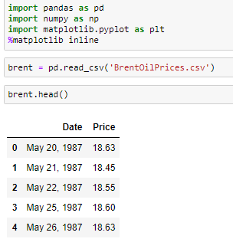

Figure 3 Showing the importation of relevant libraries for data exploration

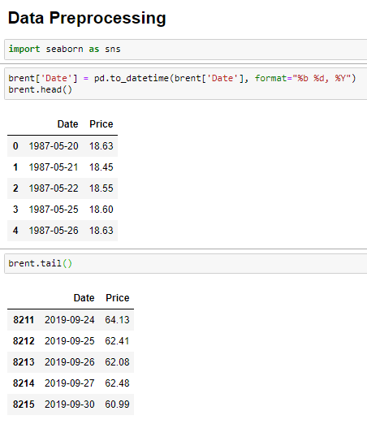

Figure 4 Showing a little data cleaning

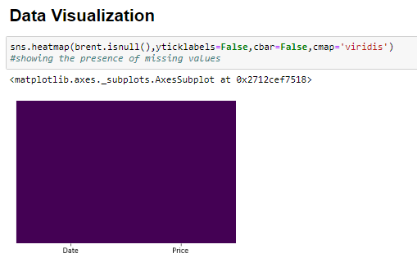

Figure 5 : Data Visualization showing the absence of missing values, giving us a perfectly balanced dataset to work with.

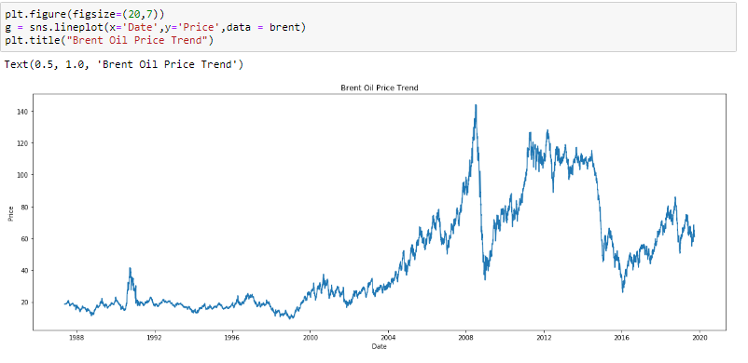

Figure 6 showing a pair plot of the trending pattern of Brent Oil Price

Prophet is imported afterwards and forecast is made. Before forecasting however, necessary data conversions is made to the understanding of the Prophet library.

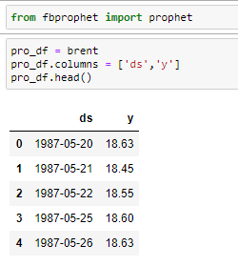

Figure 7 Showing Prophet being imported

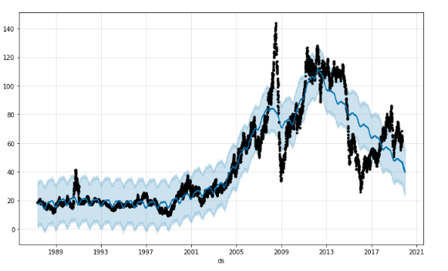

Figure 8 Showing the actual price (Black line) against the predicted/forecasted price (Blue line)

**Results and Discussion**

In this section, we evaluate the results gotten from the forecast. Before that however, it can be observed there was an abrupt increase in crude oil prices between Mid-2006 to 2009 when it reached its peak, and a vertical drop in the price. From 2016 however, there have been a steady increase and a slight fluctuation in 2019. The forecasted values from late 2019 shows a gradual dip up until 2020 as shown in figure 9 below.

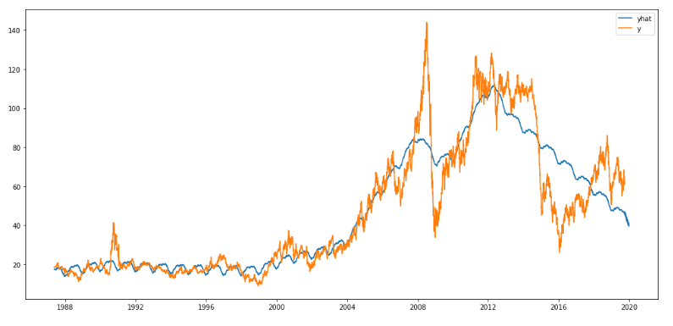

Figure 9 Showing the Actual value as "y" and the Predicted value as "yhat"

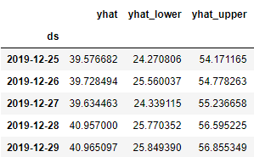

Table 10 Showing part of the predicted results

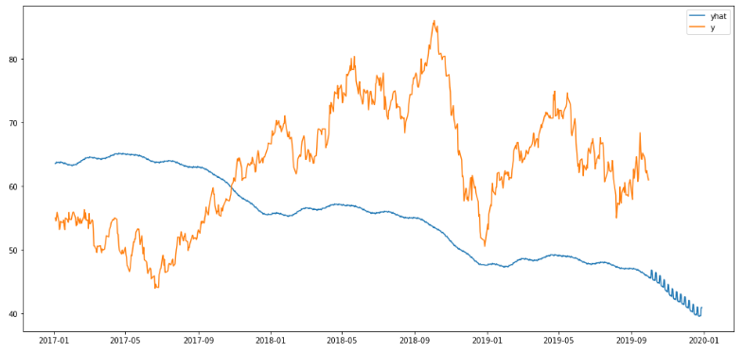

Figure 11 Comparing Forecasted Prices VS Actual Crude Prices from 2017-01 to 2020-01

**CONCLUSION**

The survival of the Oil and gas industry through the fourth industrial revolution is dependent on how Artificial Intelligence, Big data and Internet of things technologies can be harnessed. This paper reveals areas where these technologies has been explored and potential areas where it can be explored most especially in the upstream.

Furthermore, the exploitation of these technologies can see Oil and Gas companies create value that is based on innovation hence leading to a competitive and sustainable advantage. Although the application of these technologies in the upstream sector have been very appreciative however, the midstream and downstream sector seem not to have gotten a good grasp of its application in their operation. It’s therefore encouraged that more R&D investments should be made in these sectors to provide a cleaner energy for sustainability.

**REFERENCES**

[1] Hossein Hassani and Emmanuel Sirimal Silva., 2018. Big Data: a big opportunity for the petroleum and petrochemical industry, OPEC Energy Review March 2018.

[2] Abdelkader Baaziz.,2014. How to use Big Data technologies to optimize operations in Upstream petroleum industry, 21st World Petroleum Congress, Moscow, Russia 2014

[3] Feblowitz J., 2012, The Big Deal About Big Data in Upstream Oil and Gas, Paper & presentation, IDC Energy Insights,  
October 2012

[4] Sunjay and Manas Banerjee 2015 BIG DATA ANALYTICS FOR HYDROCARBON UPSTREAM INDUSTRY, World Engineering Conference and Convention, Kyoto, Japan 2015

[5] Zaidi, D., 2018. Role of Data Analytics in the Oil Industry. <https://towardsdatascience.com/here-is-how-big-data-is-changing-the-oil-industry-13c752e58a5a>

[6] Juan Pedro.2017, <https://enterpriseiotinsights.com/> Three oil and gas IoT case studies

[7] Andrew Slaughter, Gregory Bean and Arshu Mittal.,2015, <https://deloitte.com/us/en/insights-focus-internet-of-things-iot-in-oil-and-gas-industry.html>

[8] Ayn De Jesus., 2019. Internet of Things in the Oil and Gas Industry – Current Applications. <https://emerj.com/ai-sector-overviews-internet-of-things-oil-and-gas>

[9] Intel IoT., IoT Solutions for Upstream Oil and Gas. <https://Intel.com/energy>

[10] Harshit Sharma,. Applying Lux’s AI Framework for Successful Outcomes. <https://luxresearch.com/blog/uncovering-insights-in-the-upstream-oil-and-gas-industry>

[11] Facebook Prophet Library., <https://facebook.github.io/prophet/>

[12] Brent Oil Prices Dataset,. Daily Historical Brent Oil Prices available on the U.S Energy Information <https://www.kaggle.com/mabusalah/brent-oil-prices/version/2#BrentOilPrices.csv>